Oracle Database Administration Services
DATABASE CREATION ON WINTEL SERVER

Submitted to



By



CIS, Wipro Limited

Document Details

Project Name | Innogy SE
Account | CIS
IT Component/Application Title | Database Creation on Wintel server
Current Version | 1.5
List of Contributors | Chetan Patel, Saurabh Nigam, Jitenkumar Pansara, Sreya Puthukudy
Customer Contact Information

Version History
(All revisions made to this document must be listed in chronological order. All revisions must be approved. Review and Approval can be done by an internal source or by the customer)
Version | Date of Revision | Description | Author | Reviewed By | Approved By
1.0 | 05-05-2013 | Initial Draft | Chetan Patel | Saurabh Nigam | Mahesh Keshatwar
1.1 | 05-07-2015 | Document Completed | Chetan Patel | Saurabh Nigam | Mahesh Keshatwar
1.2 | 22-08-2016 | Updated document to standard format | Jiten Pansara | Saurabh Nigam | Mahesh Keshatwar
1.3 | 18-05-2017 | Wipro and Innogy Logo changed | Sreya Puthukudy | Jiten Pansara | Mahesh Keshatwar
1.4 | 20-09-2017 | Updated document to Wipro Standard format with header and footer | Sreya Puthukudy | Jiten Pansara | Mahesh Keshatwar
1.5 | 05-11-2018 | Updated Post installation steps and process to remove chargeable components. | Jiten Pansara | Ajay Zende | Santosh Badiger

Document Distribution List
S.No | Name and Company | Purpose
1 | RWEIT-ORACLEDBA | This document is about creation of Oracle Database on Wintel Server
2

TABLE OF CONTENT
1. Purpose 1
2. Scope 1
3. Installation 1
3.1 Steps To do for installtion 2
3.2 Post Installation steps
4. Reference 106

Purpose
This document is prepared for the Oracle installation and database creation.

Scope
This document is prepared for Innogy project and it contains the steps of installing Oracle software and create database on Windows server as per customers requirement.
Before Proceeding, discuss with the requester regarding the chargeable components. If they don’t need any chargeable components, we should remove it.

Kindly go through the below list:

Pack | Components | Chargeable | Default Install
Active Data Guard (GoldenGate) | Physical standby w/RTQ, Fast Incremental backup on physical standby | Yes
Advanced Compression | Data Guard Network Compression, DataPump Compression, Fast RMN Compression, OLTP Table Compression, SecureFile Compression and Deduplication | Yes
Advanced Security | Transparent Data Encryption for columns, tablespace, securefiles. Datapump export file encryption, RMAN backup encryption | Yes
Data Mining | PL/SQL API, Java API, Data miner, Predictive Analytics | Yes
Database Vault | Realms, Separation of duty, Factors, Command rules, Rule sets | Yes
In-Memory Database Cache | Static/Dynamic caching of tables, Data refresh, auto transaction, data aging, standard SQL transaction semantics, Transactional replications with active-standby pair topology, Real-time change notify usinf Transaction log API (XLA) | Yes | Yes
Label Security | Label based access control (LBAC), Multi-level security (MLS), Label Factors, Label Authorisations, Data labels. | Yes
On-line Analytical Processing (OLAP) | OLAP Cube definition, API and Metadata, Cube Materilized Views, Workspaces, SQL access to OLAP cubes | Yes
Partitioning | Table, Local, Global, Range, Hash, Interval, Reference, System, Virtual Column, Composite, Subpartition, Fast, Exchange | Yes
Real Application Clusters (RAC) | RAC, CVU, Workload, Load balancing, Failover, Advanced Security SSL/TLS | Yes
Real Application Testing | Replay, Performance, Tuning | Yes
Spatial and Graph | Spatial functions, Linear, GeoRaster, Network Data Model, Topology Data Model, Analysis and mining sub, Routing, Geocoding, Spatial Web Services, 3D, Semantic, N.B.LOCATOR | Yes
Adavnced Analytics |  | Yes | Yes
TimesTen |  | Yes
Retail Data Model |  | Yes
Communications Data Model |  | Yes
Airlines Data Model |  | Yes
Utilities Data Model |  | Yes
Change Management Pack |  | Yes | Yes
Configuration Management Pack |  | Yes | Yes
Data Masking and Subsetting Pack |  | Yes (Database Gateways) | Yes
Data Lifecycle Management Pack |  | Yes | Yes
Cloud Management Pack |  | Yes | Yes
Diagnostic Pack | AWR, ADDM, ASH, Blackouts, Dynamic Metric, Memory-access | Yes | Yes
Provisioning and Patch Automation Pack |  | Yes | Yes
Tuning Pack | SQL Access Advisor, Tuning advisor, Automatic SQL tuning, Tuning sets, SQL Monitoring, Reorganize objects | Yes | Yes
Multitenant |  | Yes
Oracle Database Lite |  | Yes (NUP & Proc)
Programmer |  | Yes
Secure Backup |  | Yes

Download and Install Software

Open a web browser of your choice and navigate to http://otn.oracle.com/windows.
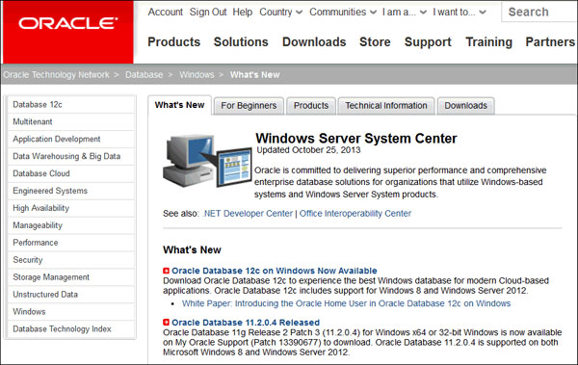
Click the Downloads tab.
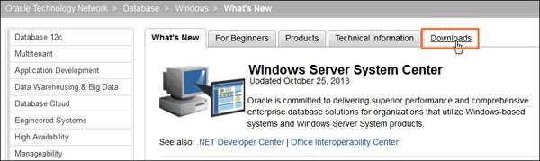
Click on the latest version of Oracle Database 12c (x64).
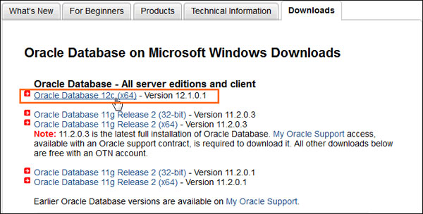
The software downloads page displays the files required to download the database. It lists a set of software files to install software such as, Oracle Database Grid Infrastructure and Oracle Database Gateways with the Oracle database. Each set displays a short description of what the file includes. You can choose to download any set of software depending on your requirement.
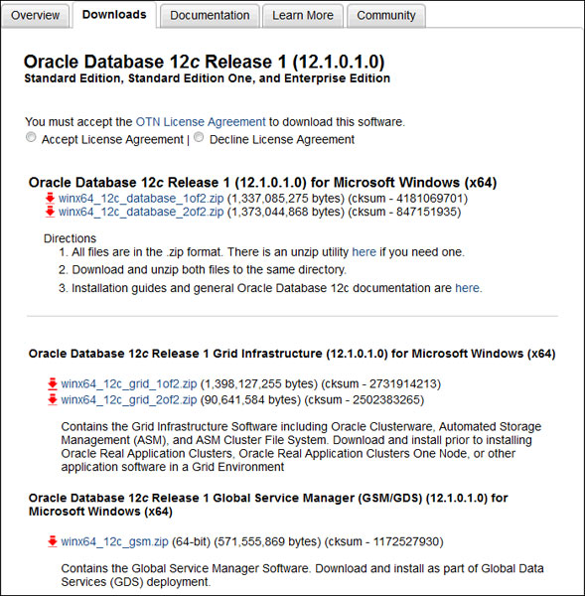
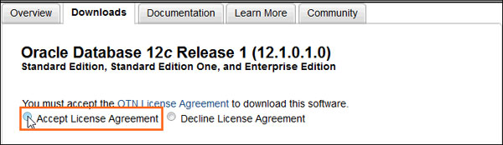
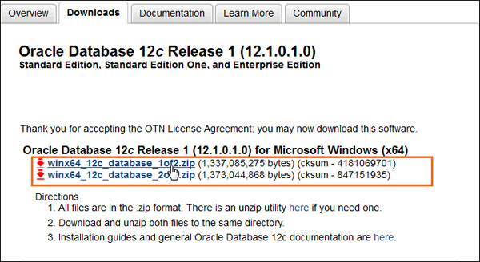
Log into your Oracle web account. If you do not have an Oracle account, click the "Sign Up" link to create one. Then choose the location where you want to download the .zip files.
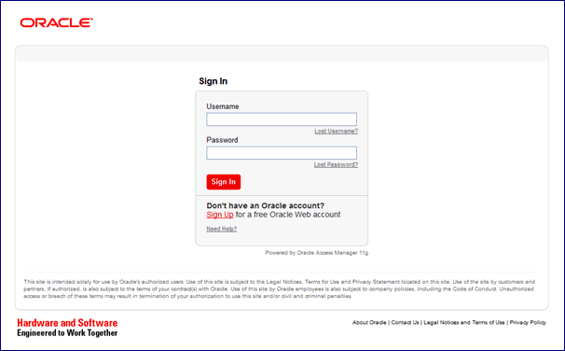
After downloading the files, use the default built-in extraction tool provided by Windows, or tools such as 7-zip to extract the .zip files. In this OBE, we use the built-in extractor to extract the software files.
Right click winx64_12c_database_1of2 and select Extract All...
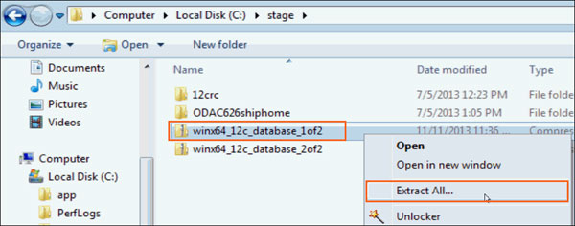
Choose the folder of your choice and click Extract. In this OBE, we extract the file to the F:\windows_db_12c\winx64_12c_database_1of2 folder.
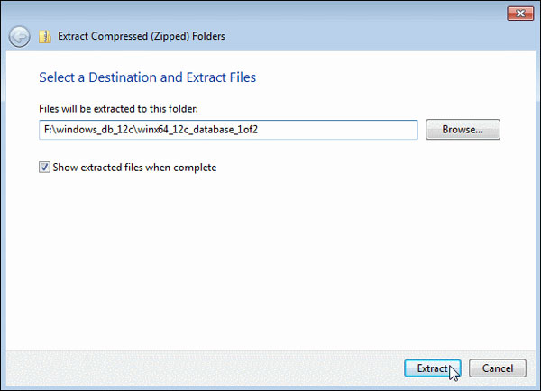
The file winx64_12c_database_2of2.zip must be extracted into the same folder where the first file was extracted. Right click winx64_12c_database_2of2.zip, select the Extract All... option and specify the same location where the first file was extracted. In this OBE, we extract the files to the F:\windows_db_12c\winx64_12c_database_1of2 folder. Click Extract.
The software files are extracted. Expand the winx64_12c_database_1 folder.
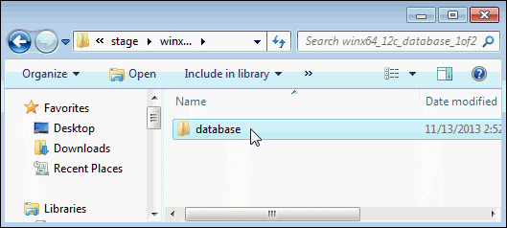

In this section, you will be installing the Oracle Database and creating an Oracle Home User account.
Expand the database folder that you extracted in the previous section. Double-click setup.
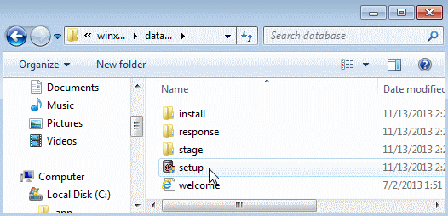
Click Yes in the User Account Control window to continue with the installation.
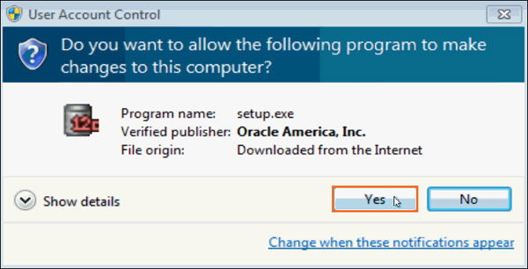
The Configure Security Updates window appears. Enter your email address and My Oracle Support password to receive security issue notifications via email. If you do not wish to receive notifications via email, deselect "I wish to receive security updates via My Oracle Support". Click Next to continue. Click "Yes" in the confirmation window to confirm your preference.
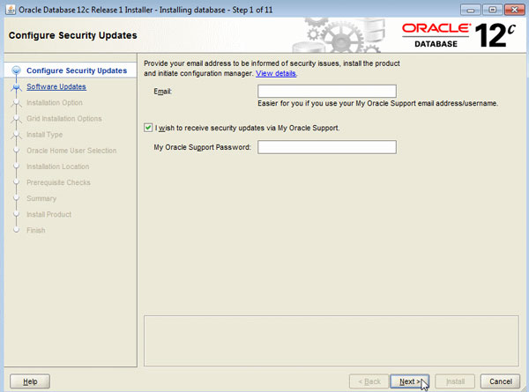
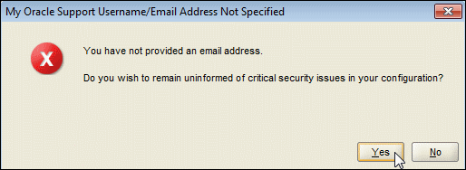
The Download Software Updates window appears with the following options:
  - Select "Use My Oracle Support credentials for download" to download and apply the latest software updates.
  - Select "Use pre-downloaded software updates" to apply software updates that you previously downloaded.
  - Select "Skip software updates" if do not want to apply any updates.
Accept the default and click Next.

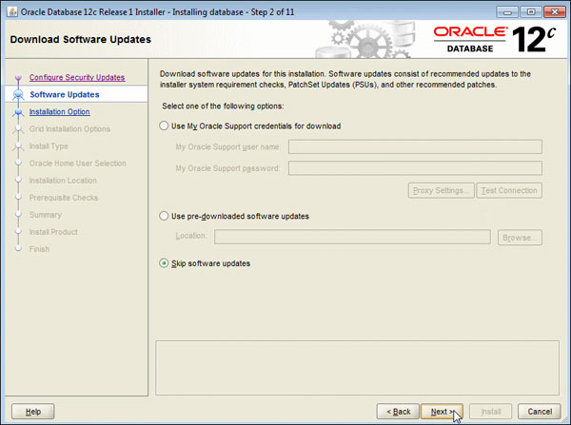
The Select Installation Option window appears with the following options:
  - Select "Create and configure a database" to install the database, create database instance and configure the database.
  - Select "Install database software only" to only install the database software.
  - Select "Upgrade an existing database" to upgrade the database that is already installed.
NOTE: Select Install database software only in case you want to remove licensing components. Steps for the same are as below.
- Stop the Oracle services
- Start DOS session and set oracle_home=h:\oracle\11.2.0.3 (or as per the Oracle software path)
- Check path has the rdbms bin directory first (set path)
- Run the chopt command for all the following options (dm, dv, lbac, olap, partitioning, rat, ode_net_2) – some may already be disabled and come back with an 'already exists' message.
- Eg: > chopt disable olap
- Writing to h:/oracle/11.2.0.3/install/disable_olap.log...
- movefile h:\oracle\11.2.0.3/bin/oraolapop11.dll h:\oracle\11.2.0.3/bin/oraolapop11.dll.dbl
- Start the Oracle services
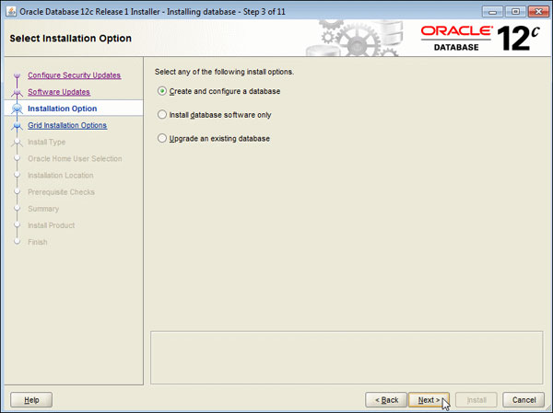
The System Class window appears. Select Desktop Class or Server Class depending on the type of system you are using.
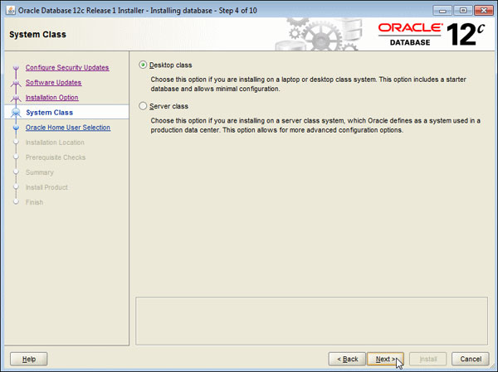
The Oracle Home User Selection window appears. Starting with Oracle Database 12c Release 1 (12.1), Oracle Database on Microsoft Windows supports the use of an Oracle Home User, specified at the time of installation. This Oracle Home User is used to run the Windows services for a Oracle Home, and is similar to the Oracle User on Oracle Database on Linux. This user is associated with an Oracle Home and cannot be changed to a different user post installation.
Select the Use Windows Built-In Account option and click next.
The Typical Install Configuration window appears. Click on a text field and then the balloon icon (  )to know more about the field. Note that by default, the installer creates a container database along with a pluggable database called "pdborcl". The pluggable database contains the sample HR schema. Change the Global database name to orcl. Enter the "Administrative password" as ******. This password will be used later to log into administrator accounts such as SYS and SYSTEM. Click Next.
As per our Standards, we should install Oracle Home on H:\drive rather than C:\drive.
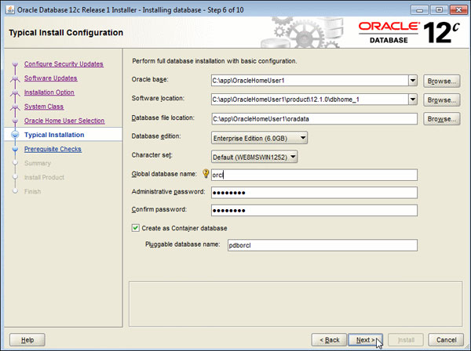
The prerequisite checks are performed, and a Summary window appears. Review the settings and click Install.
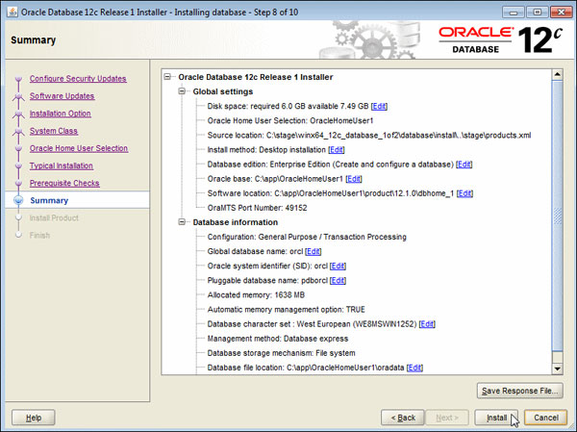
The progress window appears.
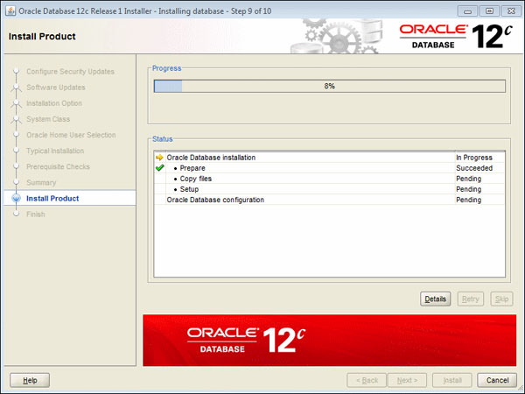
The Database Configuration Assistant creates the database.
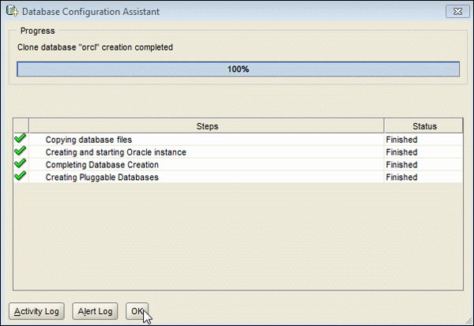
The Finish window appears. Click Close to exit the Oracle Universal Installer.
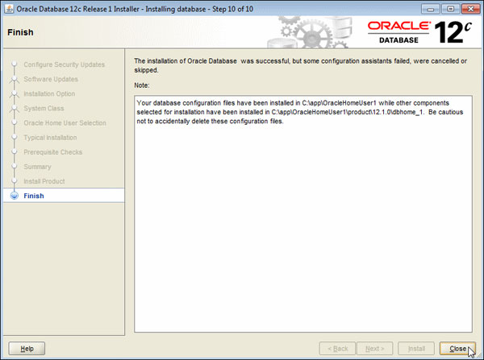

- Configure listener using netca → See document ‘Net Configuration Assistant’
- Add the following to the listener (amend for the listener <SID> name)
SUBSCRIBE_FOR_NODE_DOWN_EVENT_<SID>=OFF
ADMIN_RESTRICTIONS_<SID>=ON
See example format → listener.ora
- Add database(s) (Production and Education as required) and rman catalog RMANP to tnsnames.ora. Use DNS alias RMANP for the host for the RMANP connection. Use the actual server name for the Prism databases as the DNS aliases for these will be resolving to the intermediate servers.
→ see files/tnsnames_rdbms.ora and files/tnsnames_forms.ora for example files

- Add GROUP\FNC_ORACLEDBA_RWEIT to ora_dba group

Post Installation Steps:

• Disable diagnostics and tuning packs:
alter system set control_management_pack_access=NONE scope=both;

• Disable 'SQL Tuning Advisor':
BEGIN
dbms_auto_task_admin.disable(
client_name => 'sql tuning advisor',
operation => NULL,
window_name => NULL);
END;

• Disable AWR job.

If control_management_pack_access is set to none no metrics will be gathered but to avoid confusion run the following to stop the AWR job:
Exec dbms_workload_repository.modify_snapshot_settings(interval=>0);

Verify it: - This will work in version 11g onwards.
Select client_name, status from dba_autotask_clients;

